Emel Biçici

1802120215

FINAL PROJECT ANSWERS

5:

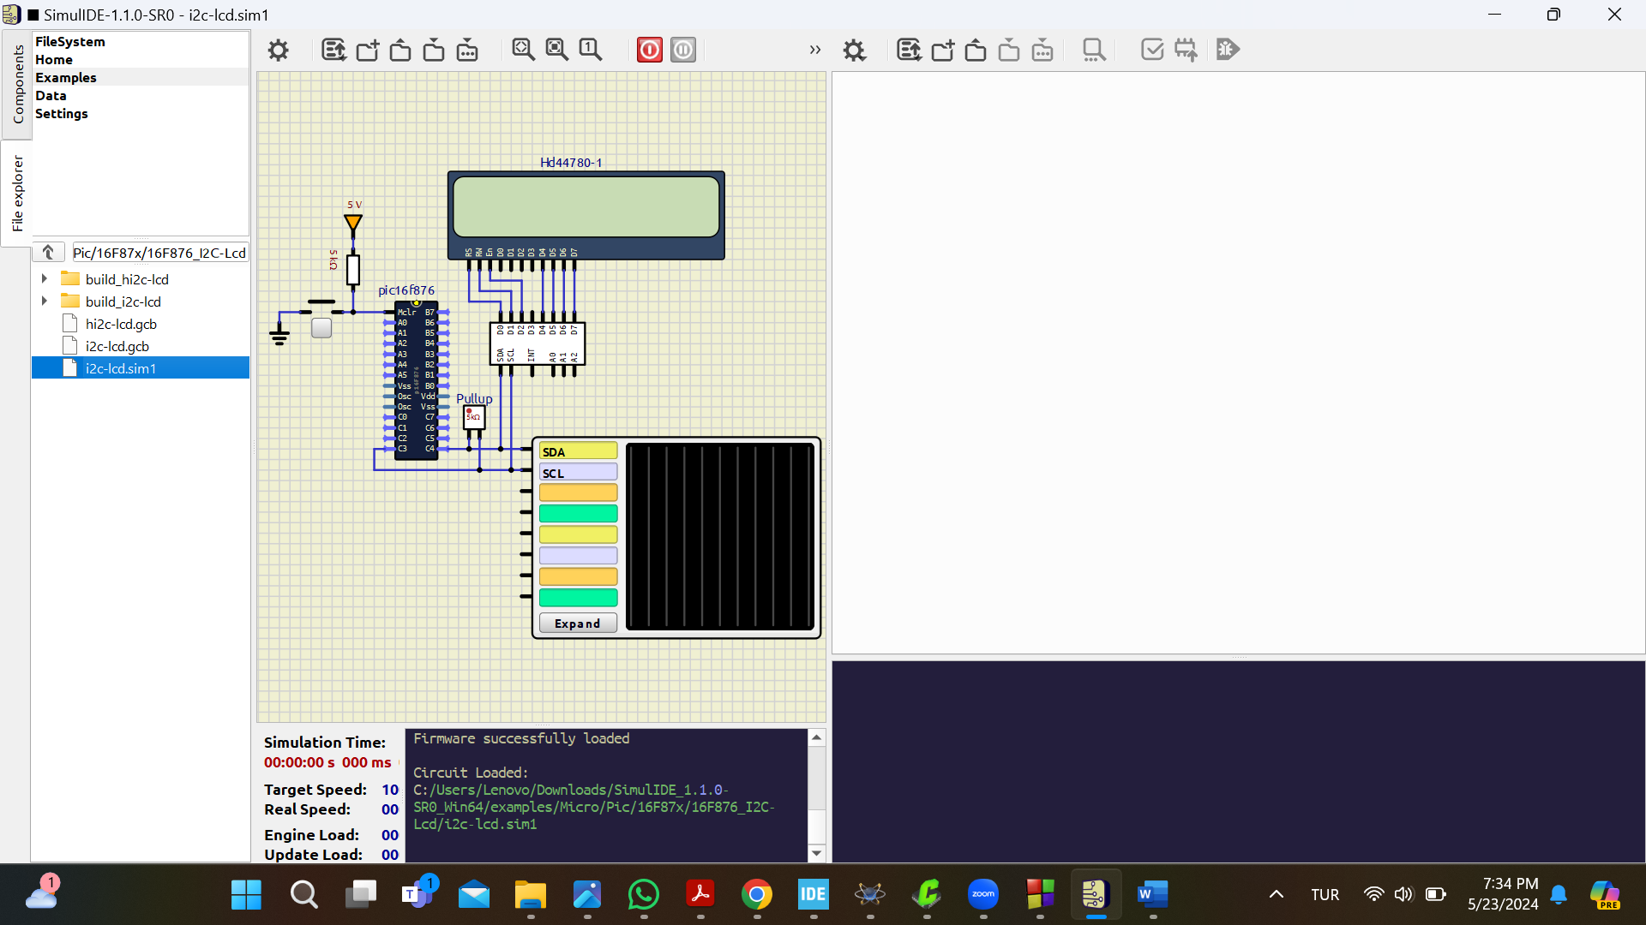

Simulation is opened as shown above.

Simulation is working and characters appear on the screen.

The push-button is tied to master clear (MCLR) pin of the microcontroller. For normal operation it should be tied to VCC through a resistor. If it is pulled to ground it puts the microcontroller in reset condition. When released the code in the controller starts from the beginning. We see this situation in the simulation.

**6:**

bcf SYSLCDTEMP,1 // clears SYSLCDTEMP register

movlw 1

movwf LCDBYTE // write 1 to LCDBYTE register

call LCDNORMALWRITEBYTE // calls the subroutine which writes a byte to LCD

movlw 4

movwf SysWaitTempMS // write 4 to SysWaitTempMS register

clrf SysWaitTempMS_H // // clears SysWaitTempMS_H register

call Delay_MS

movlw 128

movwf LCDBYTE

call LCDNORMALWRITEBYTE // writes another byte to LCD

movlw 66

movwf DELAYTEMP

DelayUS1 // delay routine

decfsz DELAYTEMP,F

goto DelayUS1

nop

return

this piece of code probably clears the characters on the LCD screen.

7:

I2C is a synchronous serial communication protocol. It is widely used in integrated circuit world where where simplicity and low manufacturing cost are more important than speed. It utilizes only two wires, other bus technologies used in similar applications, such as [Serial Peripheral Interface Bus](https://en.wikipedia.org/wiki/Serial_Peripheral_Interface_Bus) (SPI), require more pins and signals to connect multiple devices. SDA (Serial Data)  wire is used by the master and slave to send and receive data. SCL (Serial Clock) wire carries the clock signal. It can reach to the speeds like 5 Mbps.

EXAMPLES:

1) 24CW128X is a 128-Kbit I2C Serial EEPROM with Software Write Protection . It has a high-speed I2C interface up to 1 MHz.

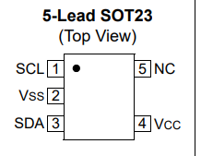

2) The PCA9554 and PCA9554A are 16-pin CMOS devices that provide 8 bits of general purpose parallel Input/Output (GPIO) expansion for I2C-bus applications.

3) MXC400xXC is a monolithic and wafer level packaged three-axis accelerometer IC with a slave mode I2C interface.

